

Course Name: Introduction to Software Engineering
Course Code: IS1103-1
Assignment Number: 1
Title: Study of Software Development Life Cycle Models with Reference to Amazon
Student Name: Anna Seric Fernandes
USN / Roll Number: NNM24IS033
Semester: IV
Section: A
Department: Information Science & Engineering
Institution Name: NMAM Institute of Technology
Academic Year: 2025-2026
Instructor Name: Dr. Jason Elroy Martis
Date of Submission: 13-02-2026

ABSTRACT
This report looks at the Software Development Life Cycle (SDLC) of the Amazon Online Shopping Application. Large number of people around the world make a good use of this application. The main problem discussed is how to manage various functional and non-functional requirements in a system that constantly changes and must handle high traffic, security, and performance demands. It compares three SDLC models: Waterfall, Incremental Development, and Spiral Model. The main focus of comparison is on how each model supports requirements management, risk control, cost, and time.
A simple requirements document includes the following key features: product search, ordering, payment, and user account management. It also sees essential quality requirements such as security, reliability, usability, and scalability. The report describes how to confirm the requirements, using stakeholder reviews, basic prototyping, and requirement verification, and looks into the issues such as changing requirements and communication gaps.
The comparison shows that the Incremental and Spiral models work better for rapidly changing systems like Amazon because they address risks and changes more effectively than the Waterfall model. According to the study, it also says that using models that let you work in steps and manage risks is the best choice for big e-commerce apps.

GITHUB REPOSITORY LINK
GitHub URL: https://github.com/annaprint28/ISE-Task-1-SDLC-

INTRODUCTION
This case study project examines the Software Development Life Cycle (SDLC) of the Amazon Online Shopping Application. The primary objective of this project is to determine how different software development process models, such as the Waterfall Model, Incremental Development Model, and Spiral Model, shape the management of requirements in an extensive system.
This assignment also includes creating a basic requirement engineering document and defining the approach to be used for the verification of requirements. Through a comparison of the various models, this assignment seeks to determine the most appropriate development model for systems requiring frequent updates, high reliability, and effective risk management.
This problem applies software engineering concepts, but large e-commerce sites such as Amazon rely heavily on deep learning as well. Deep learning techniques enhance product recommendation, search, fraud detection, and our understanding of customer behaviour. Deep learning assists in dealing with a lot of customer data and makes the experience better and more personalized.
This topic corresponds to Unit I: Introduction and Requirements Engineering. This topic includes SDLC models, requirements analysis, functional and non-functional requirements, and methods for validating requirements, which are the major topics in this unit.

PROBLEM STATEMENT
This assignment focuses on studying how the large-scale Amazon Online Shopping Application can be developed and managed using different Software Development Life Cycle (SDLC) models. The main task is to analyse and compare the Waterfall, Incremental, and Spiral models. It is necessary to know how each model affects requirements management in a complex system. The assignment also includes preparing a simplified requirements document that covers both functional requirements, such as product search, ordering, and payment, and non-functional requirements like security, performance, and reliability. Additionally, the task involves explaining how requirements are validated and the difficulties that may develop during this process.

The expected outcome is a clear understanding of which development model works best for a large and continually changing e-commerce platform. The report should show how different models handle risks, changes in requirements, time, and costs. It should also highlight how proper requirements engineering can improve software quality and minimize development issues.
This study assumes the Amazon application is a large, evolving system that serves many users and receives frequent updates. Since we do not have access to Amazon's real internal data, the analysis draws on general knowledge of e-commerce systems and standard software engineering practices. Time and resource limitations are also considered as we simplify the requirements and system scope.

SYSTEM DESCRIPTION
The Amazon app is a large-scale operation since it is world’s biggest marketplaces. It is one of the busiest hubs where countless shoppers are in search of deals, vendors manage their stock, and admins work behind the scenes to keep everything safe. From tracking a package to processing a payment, there is a lot of data moving at any given second.
One of the major things that make Amazon different and unique is that it never stays motionless. It’s a "living" system that is constantly changing. Whether it’s a new recommendation tool, a flash sale, or a faster shipping method, new features are added almost daily. Because of this, the requirements for the system are always shifting—it’s not a project where you can just "set it and forget it."
The stakes are very high. The app has to be very reliable to protect customers credit card info. It cannot crash during big Sales like Prime Day etc and it should be very fast in order to keep the impatient shoppers happy and exciting. If it takes longer time or some technical problems appear, shoppers can simply leave.
Amazon is a perfect example to use when looking at different development models because it is so huge, challenging and rapidly evolving. It requires a way of building software that can handle constant change in application and high risks. This makes it a great case study for comparing different approaches, like the rigid Waterfall method versus more flexible, step-by-step models.

TOOLS AND TECHNOLOGIES USED
- Documentation tool: Microsoft Word
- Diagram: Draw.io
- Repository hosting: GitHub

IMPLEMENTATION
The Amazon Online Shopping App is developed using SDLC and requirements engineering. We describe functional requirements such as login, product search, cart, orders, and payments, in addition to non-functional needs like security and performance.
The system consists of modules such as user management, product catalogue, cart, and payment. Development follows the Incremental model, where we build features step by step and test them through unit, integration, system, and user testing.
After testing, the app is launched on cloud servers. Maintenance includes fixing bugs, updates, and adding new features.

1.Waterfall Model – Explanation for Amazon App
The Waterfall model is a linear process where each phase has to be completed before moving on to the next [1][2]. For an app like Amazon, this indicates that every aspect, from the shopping cart to payment security, has to be completely figured out and solidified before any actual app development can begin.
Once the plan of action is determined, the process proceeds to Design and Implementation, requirement, testing, deployment [1]. The app developers will create the app exactly as it was originally designed. Once the code is confirmed, the app is Tested for errors and finally deployed to the world.
But this process is also very rigid and difficult to change one development begins [2]. Since Amazon operates in a fast-changing market, they may have to implement new features or updates in the middle of the process. In the Waterfall process, it is difficult, takes a lot of time, and costly to implement changes once the project has begun.
In the end, we can say that, the Waterfall process is not best suited for Amazon. It avoids from being adaptable quickly to new business needs and fast-paced trends due to the inflexible nature of this process. One way process is too limiting for an app that needs constant updates.
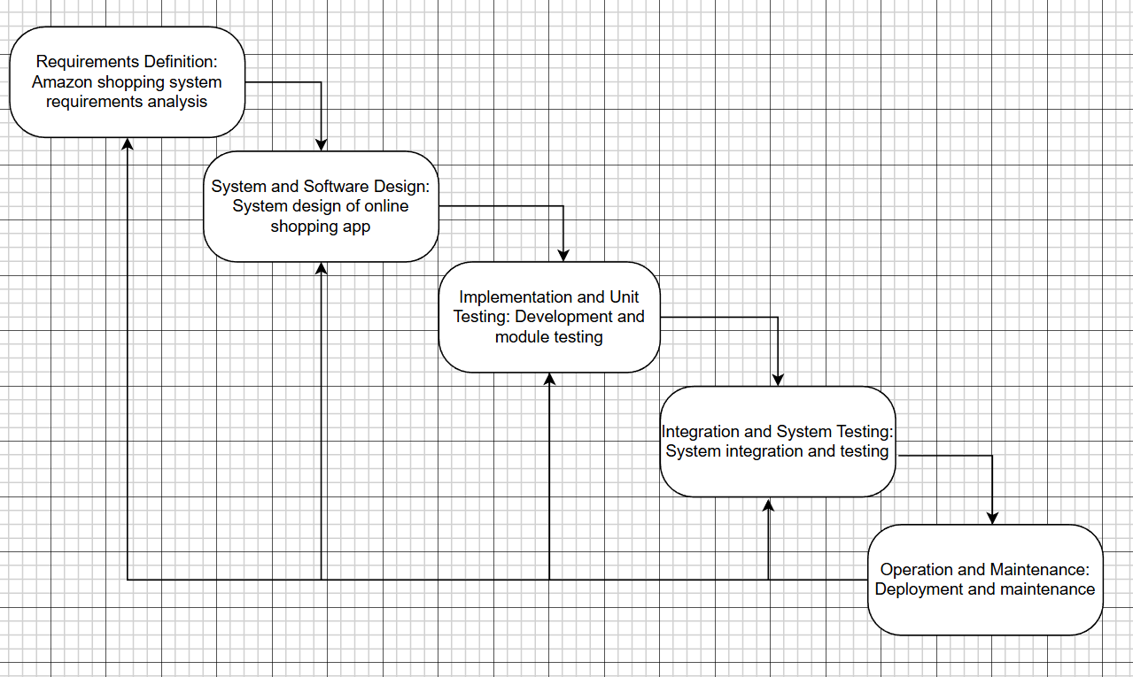

2. Incremental Model – Explanation for Amazon App
The Incremental model breaks down the system into small pieces where each increment goes through analysis, design, coding, and testing [1][2]. It is suitable for Amazon. Rather than building everything in one go, the app is broken down into modules. The initial part might involve user registration and browsing products. The subsequent part would involve the shopping cart and ordering products. Later parts would involve payment, tracking of deliveries, and customer reviews.

Each part is developed by following analysis, design, implementation, and testing. After each release, feedback is gathered, and enhancements are incorporated. This helps in dealing with changes in requirements [2]. For instance, if Amazon wishes to incorporate a new functionality such as “same-day delivery,” it can be incorporated in a later part without affecting the entire system.

This model enables early delivery of functional capabilities, improved user feedback, and step-by-step enhancement of non-functional requirements such as performance and usability. Therefore, it suits Amazon’s changing system.
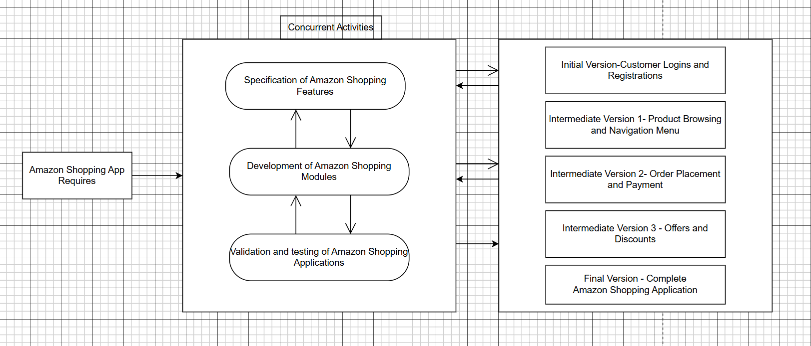

3. Spiral Model – Explanation for Amazon App
The Spiral model combines repetitive work and iterative deployment with thorough risk analysis [2][4]. Every cycle consists of four stages: planning, risk analysis, development, and review [4]. For Amazon, some risks might be security threats to payment, server overload during peak hours, data privacy issues, and integration issues.

During planning, objectives like implementing a new payment system are defined. During risk analysis, potential risks such as fraud or system failure are considered [4]. Next comes development and testing, followed by review with user feedback. The next cycle begins with better requirements.

As Amazon deals with confidential information and a huge amount of traffic, risk management is a critical aspect. The Spiral model identifies technical, monetary, and security risks early on and tackles them with utmost care. It might be time-consuming and expensive, but it is highly reliable and robust. Therefore, it is suitable for a complex system like Amazon.
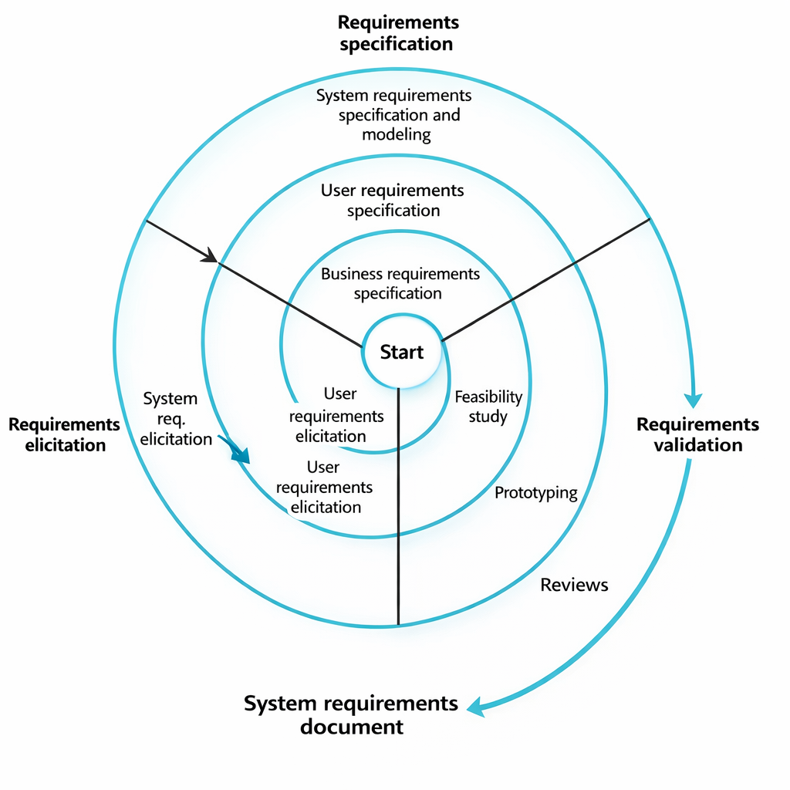

REQUIREMENT DOCUMENTS
Functional Requirements
Functional Requirements defines what the system must really do [3]. The Amazon shopping app should let users create accounts, log in, and manage their profiles, addresses, and payment details. Users should be able to search for products, browse categories, view product details, and see recommendations.
The system should allow users to add items to the cart, change quantities, and remove products. It must encourage a smooth and easy checkout process where users select delivery options and make payments safely. After ordering, users should track orders, see order history, cancel items (when allowed), and request returns or refunds. Notifications about orders, offers, and delivery updates should be sent.
Admins must manage products, prices, users, and reports. Sellers should upload products, update stock, and track sales.

Non-Functional Requirements
Non-Functional Requirements explains performance, security, and experience elements [3]. The app must be safe to protect user data and payment information. It should be quick and responsive, even during busy network. The system should be efficient and dependable with very little service interruption and must recover quickly from issues.
It should be flexible to handle millions of users at once. The app must be easy to operate, available 24/7, and simple to maintain with regular updates.

Requirements Validation Strategy
In order to make sure all key features are clear and complete, the requirements are inspected by stakeholders. Users can confirm the system flow since simple prototypes may be used. Each requirement is verified to ensure it meets the business objectives, such as security and performance.
Test cases are created to check each requirement, and consistency checks are done to remove clashes and to make sure that the system is workable to build.

Challenges in Requirements Engineering
Requirement validation makes sure the system requirements are correct, complete, and constant [3]. The system keeps transforming so the requirements quiet oftenly change. Trying to understand the needs of many different users can also be difficult and hectic, leading to misunderstandings and complications. There may be conflicts between requirements, such as security versus performance. Managing requirements for such a large and complex system is itself a huge challenge.

COMPARISONS
Handling Functional Requirements
The Waterfall model only works well and good when all the aspects of characteristics are picked in the beginning. But for Amazon, that’s almost impossible because new features, offers, and services keep getting added. The Incremental model is more hands-on since features can be designed and added step by step. The Spiral model is even more adaptable because in every phase, requirements are reviewed and improved. This makes it very ideal for a system that keeps evolving and building like Amazon.

Handling Non-Functional Requirements
Since huge population of people use Amazon at the same time, things like data security, pace, and scalability are highly at importance. In Waterfall model, these components are decided in very well in advance so changing them later is harder. In Incremental model, it improves these qualities over time with every update.

Risk Management
The Waterfall approach does not care much about risk during the development phase. If there is a problem, it is usually discovered at the end. The Incremental approach reduces risk by testing each increment before proceeding. The Spiral approach is best at risk management since risk analysis is an integral part of every phase. This is very important for Amazon because even a small problem in the system can result in a huge loss.

Change Management
The Waterfall approach makes it very difficult to go back and change something after completing a phase. The Incremental approach is better in this regard because changes can be made between the increments. The Spiral approach is the most flexible because every phase allows changes to be made to the requirements. This is very important for an application like Amazon, which keeps changing all the time.

Time Constraints
The Waterfall approach takes longer because you do not get to see the final product until all phases are completed. The Incremental approach allows you to see the light at the end of the tunnel because it lets you see working versions of the product early on. The Spiral approach takes longer because of all the testing and analysis involved. However, this extra time results in a better system.

Cost Constraints
The Waterfall approach appears to be the cheapest at first because it does not require much spending initially. However, if changes are required, the cost skyrockets. The Incremental approach allows the cost to be spread over multiple phases. The Spiral approach is the most expensive because of all the risk analysis and iterations involved. However, the Spiral approach also reduces the risk of failure, which ultimately saves money in the long run.

USER FEEDBACK
In the Waterfall model, users typically get to see the system only at the end, so feedback is received much later. In the Incremental model, users give their feedback after each release. In the Spiral model, users are made to involve regularly throughout the process, which is very helpful in continuously improving the system step by step.

APPLICABILITY TO AMAZON APPLICATION
For Amazon, the Waterfall model is not very suitable since it is not able to deal with changes. The Incremental model is very appropriate since it allows the progress of qualitative features incrementally. However, the Spiral model is the most appropriate since it deals with risks, copes with frequent changes, and maintains the system’s consistency.

LIMITATIONS AND FUTURE WORK
This is more of a project where we examine various SDLC methodologies and discuss system requirements rather than developing the actual Amazon app. There was no actual coding, testing, or user data involved. Some assumptions had to be made about how the system would function, which may not be the actual case.
In the future, it would be beneficial if we were to develop a functional prototype and test it on actual users. We could explore more advanced features such as smart recommendations, enhanced security, and quick search.
The study can be further extended by examining various development methodologies and utilizing more efficient tools for requirements and testing.

RESULTS AND ANALYSIS
According to the study, it shows that different SDLC models upgrades the development of the Amazon app in various ways. The Waterfall model provides a well-structured process but struggles to execute when the requirements change. Basically, using iterative models like Incremental and Spiral makes it easier to release features quickly, fix problems as they come, and handle things like security or performance issues, which works really well for fast-changing e-commerce apps like amazon.

CONCLUSION
It can be concluded that with this, case study project tested the SDLC of Amazon online shopping app by comparing waterfall, Incremental and Spiral models. It was discovered how requirement validation is done by creating a simple requirements doc. The results showed how each model addresses functional and non-functional requirements, risks, difficulties, time and cost.
The key point here is, for the success of a project, selecting the appropriate development model is very important. Waterfall is not very flexible, Incremental development allows you to develop in phases, and Spiral development provides excellent risk management and opportunities for continuous improvement.
In conclusion, the Incremental and Spiral models are more appropriate and desirable for large-scale e-commerce applications such as Amazon because they provide greater flexibility, reliability, and requirements management.

REFERENCES
[1] Ian. Sommerville, Software Engineering, 10th ed., Pearson, 2016.
[2] R. S. Pressman and B. R. Maxim, Software Engineering: A Practitioner’s Approach, 8th ed., McGraw-Hill Education, 2015.
[3] K. E. Wiegers and J. Beatty, Software Requirements, 3rd ed., Microsoft Press, 2013.
[4] B. Boehm, “A Spiral Model of Software Development and Enhancement,” Computer, IEEE

DECLARATION OF ACADEMIC INTEGRITY
I hereby declare that this assignment is my original work and has not been copied or plagiarized from any source. All references and resources used have been properly cited. Any ambiguities will lead to forfeiting my marks.


Signature:

Date :13-02-2026

